|  |  |  |  |  |  |
| --- | --- | --- | --- | --- | --- |
| Date | 30-Nov-22 | | | Tester Name | Shahabuddin Syed |
| Environment | Penfax - Test | | | Login used |  |
| Operating System | Windows | Version: | Update: | | |
| Software Used | Edge | Version: | Update: | | |
| Select Software | Version: | Update: | | |
| Release version | 22.4.1 | | | | |
| Title | M49.01 – Data Posting Batch | | | | |
| Test Type | Regression | | | | |
| Test Scenario | Data Posting Batch Header Screen detail | | | | |
|  |  | | | | |
| Expected Results |  | | | | |
| Pass/Fail | Pass | | | JIRA# | 6597 |

Describe your steps with screenshots:

Login into Penfax application

Click on Batches

Select Data Posting Batches from the dropdown list

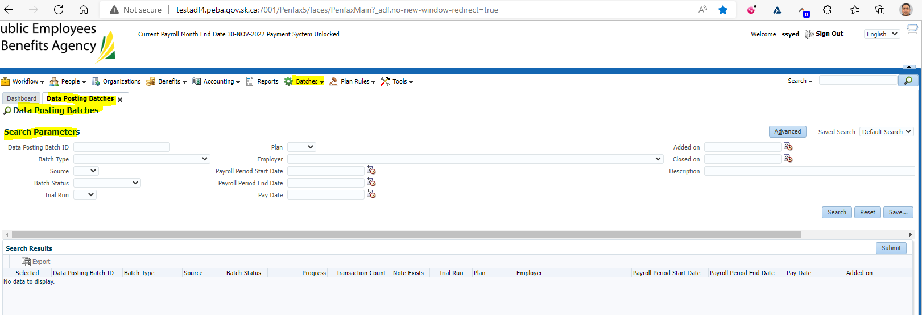

Click on Search under Search Parameters

Select Plan as ‘MEPP’

Verify if all the Header screen details are displayed

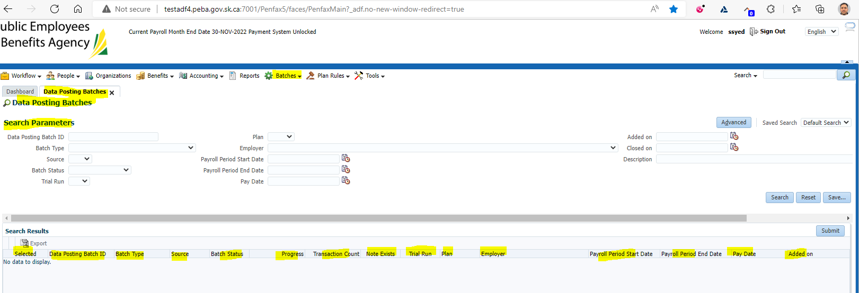

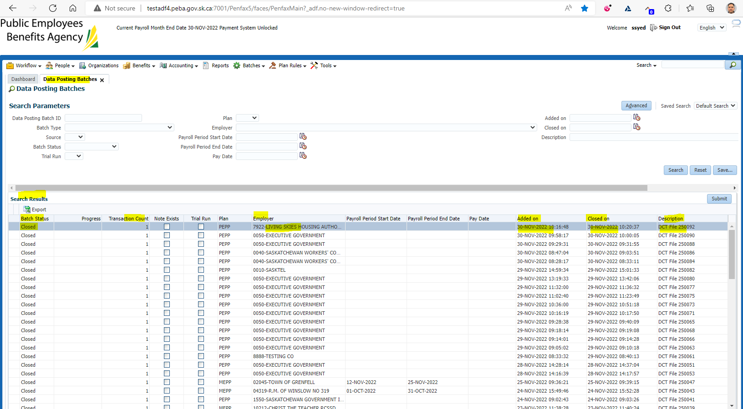

Result: Pass